Computer Networking Practicals

1. To Study and perform PC to PC communication.

Steps:

1. Drag and drop 2 PCs and connect them through a wire.

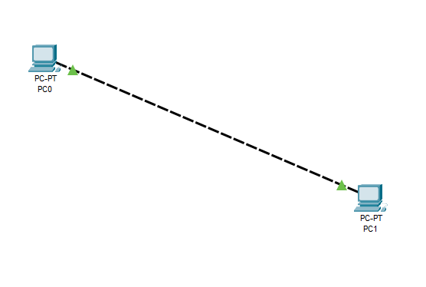

1. Double click on the PCs and assign them a static IP address.

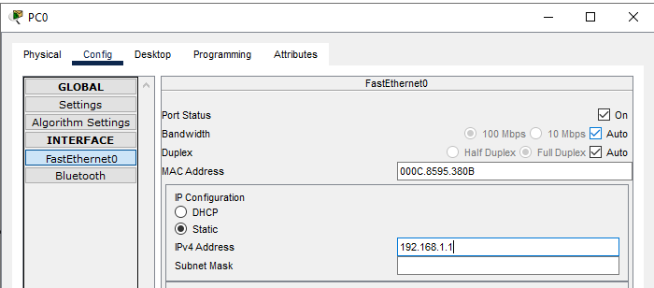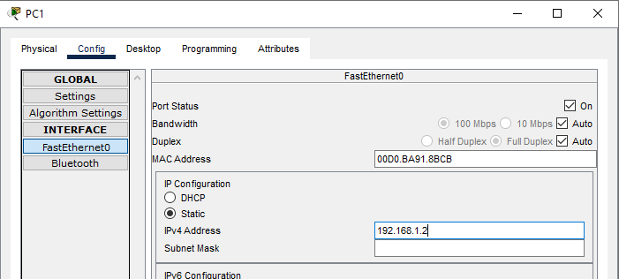

1. Try sending a packet from one to another or run a ping command in cmd.



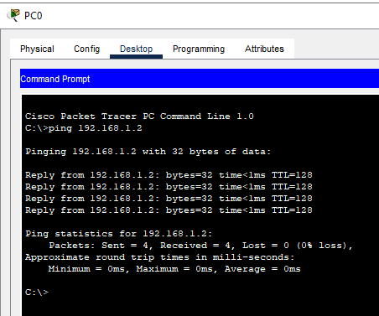

1. To create a star topology using hubs and switches.
2. ADD 6 PCs and connect them in a star manner with a central switch

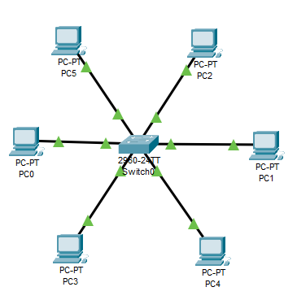

1. Configure IP addresses for all devices
2. Try sending packets from one PC to another.

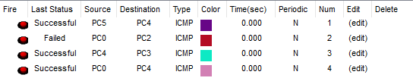

1. To create bus, ring, tree, hybrid and Mesh topologies.
2. BUS topology:

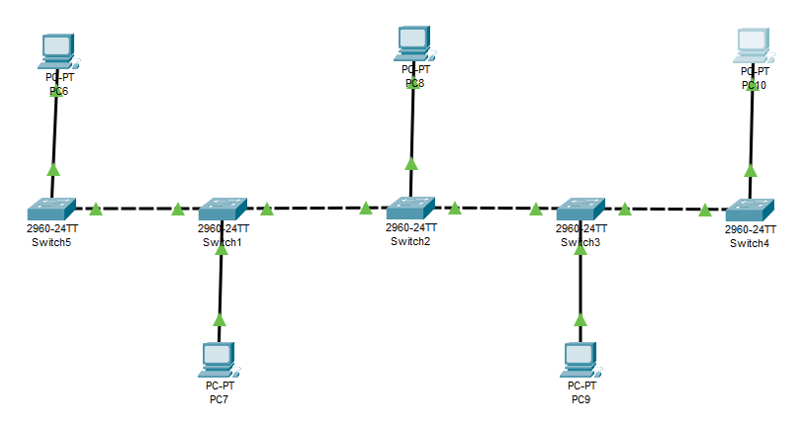

Testing after configuring IP addresses:

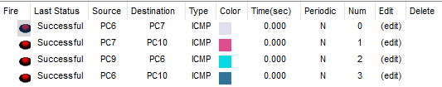

1. Mesh topology: Setup and configuring PCs and Switch

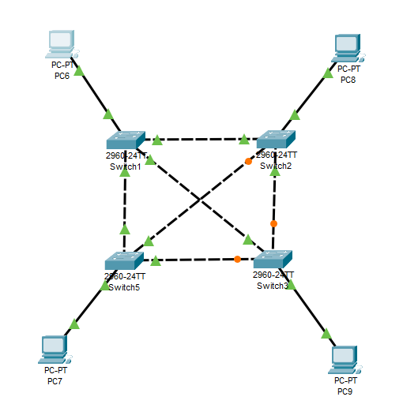

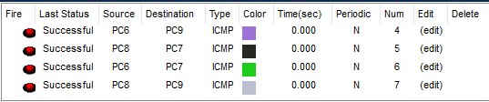

1. Tree Topology:

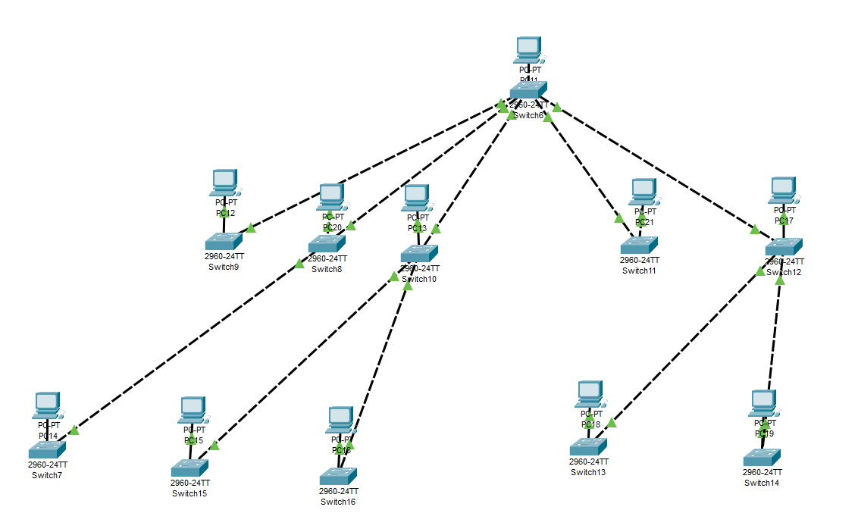

Connect every PC to a unique switch and connect them in the above design scheme and configure IP addresses for each PC.

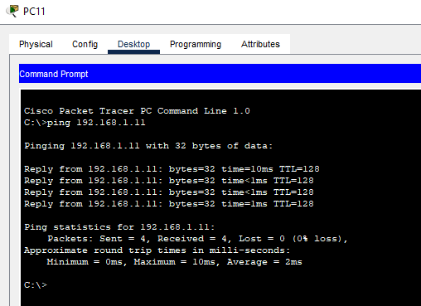

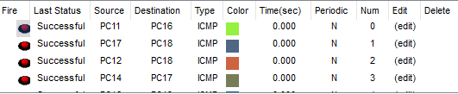

1. Hybrid topology:

A hybrid network topology is an interconnection of two or more basic network topologies, each of which contains its own nodes. The resulting topology will exhibit characteristics of all the constituent topologies, thereby limiting the inherent weaknesses of each topology.

Setup and design schema:

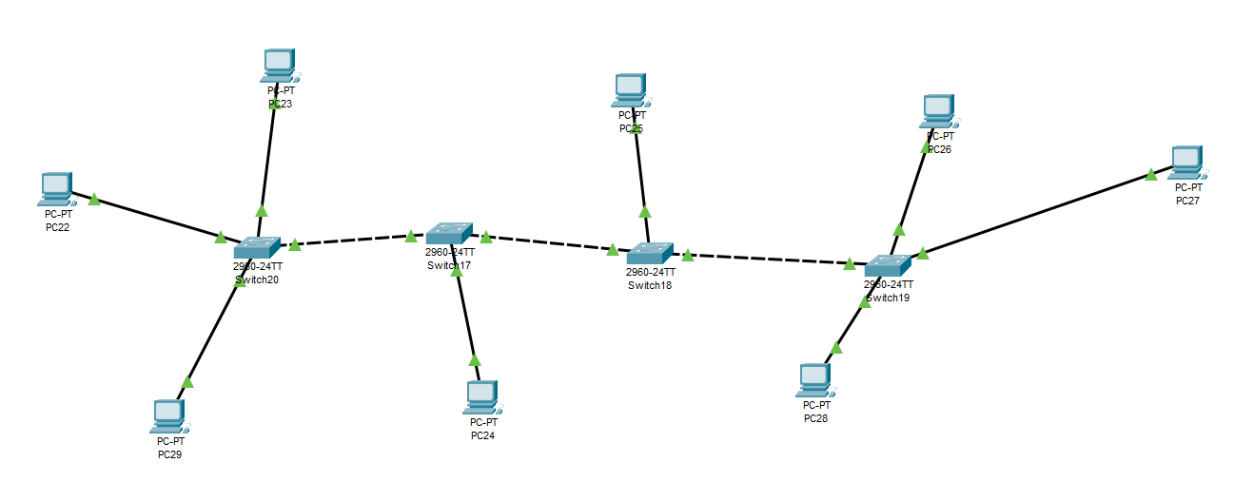

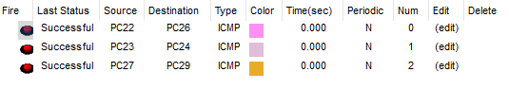

1. Ring Topology:Setup and configuring PCs and Switch

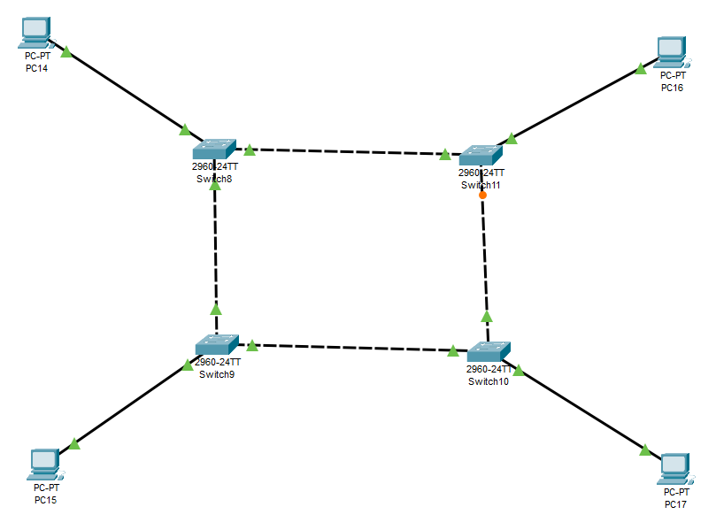

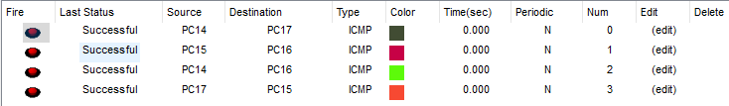

1. Perform initial switch configuration.

Open CLI of a switch in cisco packet tracer simulator and use below code snippets to perform some basic initial configurations.

1. Hostname:

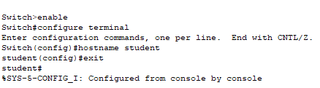

1. Password:

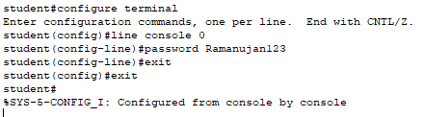

1. Interface configuration:

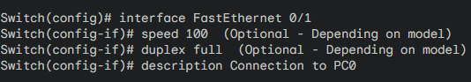

1. Perform an initial router configuration.
2. Interface configuration:

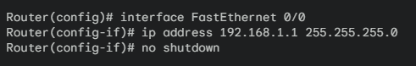

1. Hostname:

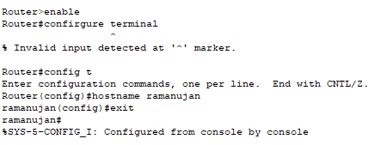

1. Password:

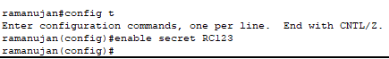

1. To implement connection between devices using a router.
2. Connect 2 PCs to a router and configure IP addresses for both PCs

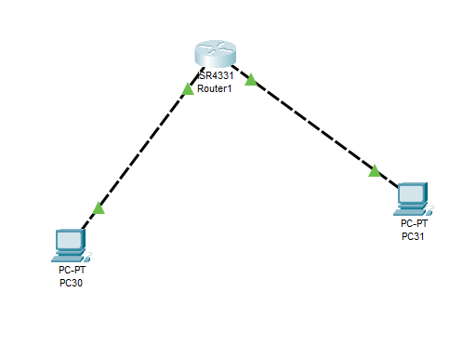

1. Configure the router and enter IP addresses for both ports:

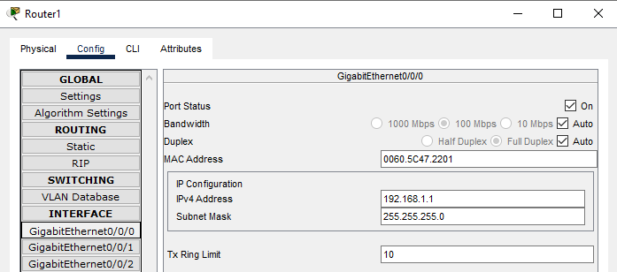

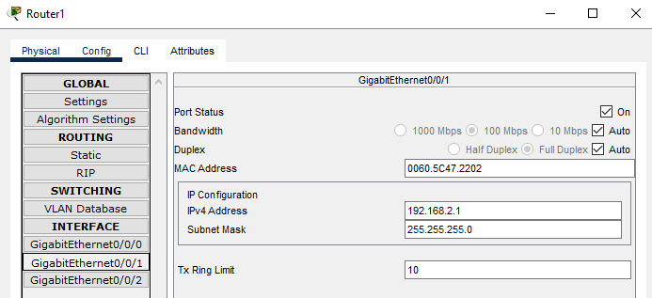

1. Configure Gateway for the PC’s:

The same IP which was used in the router for the ports will be entered in the gateway for the PC’s.

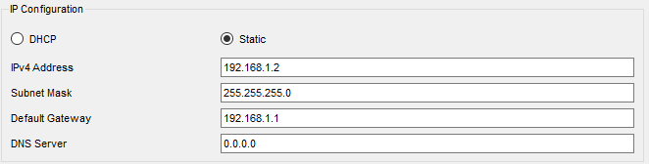

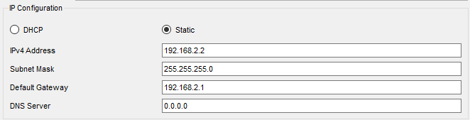

1. Testing via packet transfer:

r3

1. To implement Client Server Network.
2. Connect 3 PC’s to a switch, then connect the switch to a server.

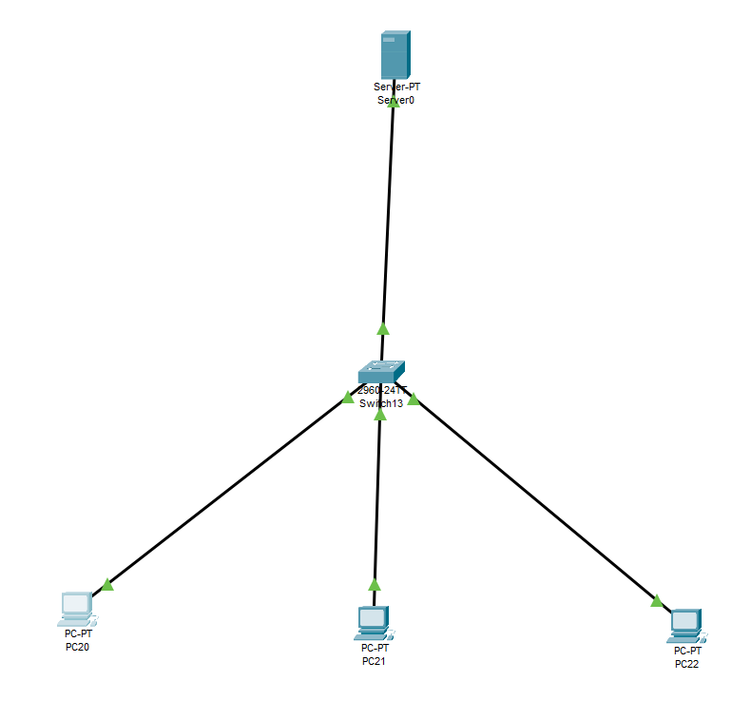

1. Now configure the server as done below:

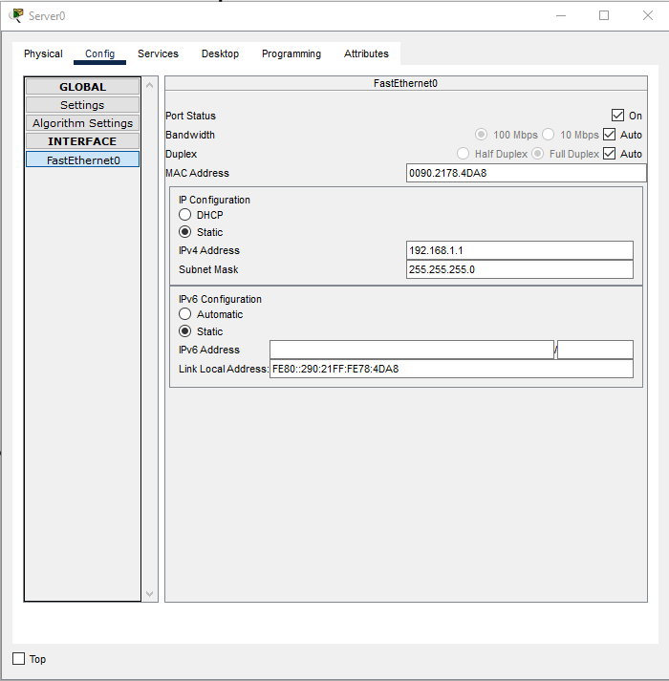

1. Now click on services, DHCP and change the default gateway, start IP address and max no of users and then save.

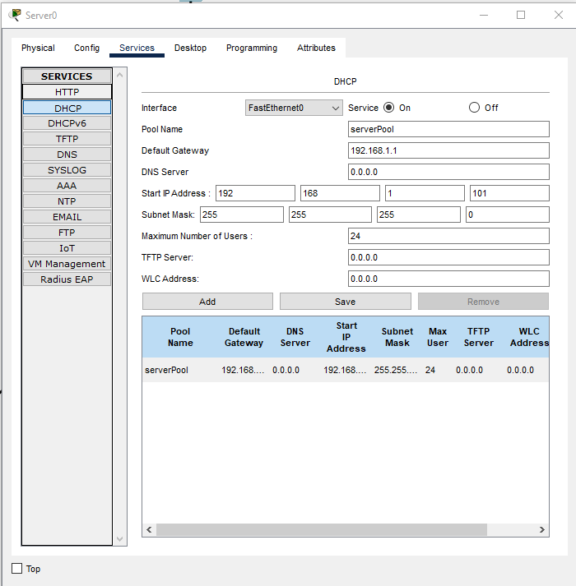

1. Now go to config settings and change the default gateway here as well.

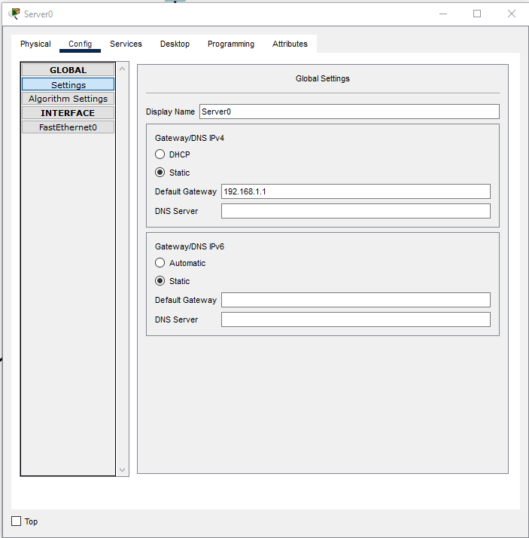

1. Now go to each PC’s IP configuration and click on DHCP.

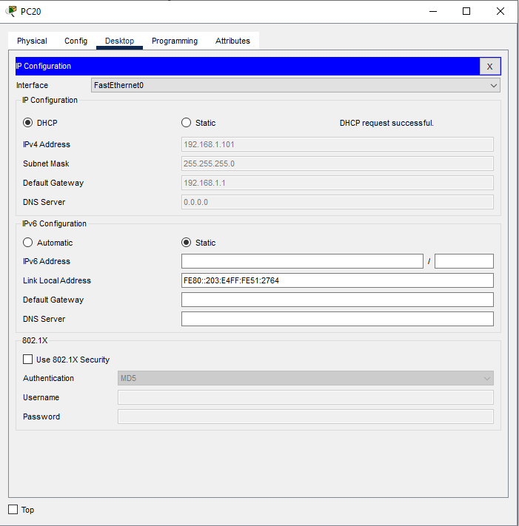

1. Testing via packet transfer.

